PROJECT COORDINATION AND SOFTWARE QUALITY ASSURANCE AT YODDHA LAB PVT. LTD.

An Internship Report


Submitted By:
Name: Taweshal Dev Thakur
KIST College of Information Technology
Exam Roll No: 370347
P.U. Reg. No: 058-3-2-05311-2022
Submitted To
Office of the Dean
Faculty of Science and Technology
Purbanchal University
In partial fulfillment of the requirements for the degree of
Bachelor of Information Technology (BIT)
Kathmandu, Nepal
July, 2026

APPROVAL SHEET
(This page is printed by the BIT Department on the college letterhead after the student submits the required details. It carries the recommendation and the signature of the BIT Coordinator. Replace this placeholder page with the signed approval sheet before final binding.)

INTERNSHIP COMPLETION LETTER
(Attach here the colour print of the Internship Completion and Employment Certificate issued by Yoddha Lab Pvt. Ltd., dated 27 July 2026, signed by the Head of Human Resource. The original letter is inserted in the hard copy.)

DECLARATION
This is to certify that I have completed the Internship Report entitled “Project Coordination and Software Quality Assurance at Yoddha Lab Pvt. Ltd.” under the guidance of Deepak Khadka in partial fulfillment of the requirements for the degree of Bachelor of Information Technology (BIT), Faculty of Science and Technology, Purbanchal University. This is my original work and I have not submitted it earlier elsewhere.

………………………………
Name: Taweshal Dev Thakur
P.U. Regd. No.: 058-3-2-05311-2022
Exam Roll No.: 370347
Date: [DD Month 2026]

CERTIFICATE
This is to certify that the internship report entitled “Project Coordination and Software Quality Assurance at Yoddha Lab Pvt. Ltd.” is an academic work done by Taweshal Dev Thakur submitted in the partial fulfilment of the requirements for the degree of Bachelor of Information Technology (BIT) at Faculty of Science and Technology, Purbanchal University under my guidance and supervision. To the best of my knowledge, the information presented by him in the internship report has not been submitted earlier.

………………………………
Signature of the Supervisor
Name: Deepak Khadka
Designation: Head of Department (HOD)
Date: [DD Month 2026]

ACKNOWLEDGEMENTS
The successful completion of this internship and report owes much to the guidance and support of several individuals and institutions. Sincere gratitude goes to the supervisor, Deepak Khadka, Head of Department, KIST College of Information Technology, for continuous guidance, constructive feedback, and encouragement throughout the internship period and during the preparation of this report.
Gratitude is also extended to the faculty members and the BIT Department of KIST College of Information Technology for building the academic foundation on which this internship stood, and to Purbanchal University, Faculty of Science and Technology, for making the internship an integral part of the Bachelor of Information Technology program.
Special thanks go to Yoddha Lab Pvt. Ltd. for providing the internship opportunity, and in particular to Sulochana Kadel, Head of Human Resource, along with the project management, product, development, and quality assurance teams, whose mentorship and cooperation made the ninety days both productive and memorable. The confidence the organization showed through the subsequent offer of full-time employment is deeply appreciated.
Finally, heartfelt appreciation goes to family and friends for constant support and motivation during the entire period of study and internship.

………………………………
Taweshal Dev Thakur

ABSTRACT
This internship report presents the work performed during a ninety-day internship at Yoddha Lab Pvt. Ltd., a software company located in Chabahil, Kathmandu, from 16 March 2026 to 3 July 2026, undertaken in partial fulfillment of the requirements of the Bachelor of Information Technology (BIT) program of Purbanchal University. The internship progressed through two complementary phases. In the first phase, as an Associate Project Manager Intern, the work focused on supporting project planning, tracking and execution; coordinating among the development, product and operational teams; assisting in monitoring milestones and deliverables; and preparing project status updates and documentation. In the second phase, as a Quality Assurance (QA) Intern for the company’s Nepal HRMS product, the work involved studying product requirements, preparing test scenarios and test cases, performing functional, regression and usability testing, identifying and tracking defects, collaborating with developers on issue resolution, and validating fixes before deployment. The report describes the industry and organizational context, analyses the activities performed and the problems solved, and reflects on the lessons learnt regarding software development processes, organizational culture, and the gap between classroom theory and industry practice. The internship concluded with an appointment as a full-time Junior Quality Assurance Developer, reflecting the practical competence developed during the period.

TABLE OF CONTENTS
Right-click here and choose “Update Field” to generate the Table of Contents.

LIST OF TABLES
Table 1.1: Internship Duration and Phase-wise Placement 0
Table 4.1: Weekly Project Status Report Format 0
Table 4.2: Sample Test Case Format Used for Nepal HRMS 0
Table 4.3: Defect Severity Classification with Examples 0
Table 4.4: Tools and Platforms Used During the Internship 0
Table 4.5: Mapping of Internship Objectives to Activities and Outcomes 0

LIST OF FIGURES
Figure 1.1: Internship Placement and Work Flow 0
Figure 3.1: Organizational Structure of Yoddha Lab Pvt. Ltd. (Indicative) 0
Figure 4.1: Software Testing Life Cycle Adopted for Nepal HRMS 0
Figure 4.2: Defect Life Cycle Followed During Testing 0

ABBREVIATIONS
BIT Bachelor of Information Technology
BS Bikram Sambat
HR Human Resource
HRD Human Resource Department
HRMS Human Resource Management System
ICT Information and Communication Technology
IIDS Institute for Integrated Development Studies
ISP Internet Service Provider
IT Information Technology
NTA Nepal Telecommunications Authority
PU Purbanchal University
QA Quality Assurance
SDLC Software Development Life Cycle
STLC Software Testing Life Cycle
UI User Interface
UX User Experience

CHAPTER I

INTRODUCTION

1.1 Background
An internship is a structured period of practical engagement in which a student works within a real organization and exchanges services for experience. It exposes the student to genuine working situations, professional discipline, and the daily rhythm of an organization in a way that classroom study alone cannot. Beyond skill development, an internship helps a student confirm interest in a particular career path, build a network of professional contacts, and earn academic credit, while giving the organization an opportunity to evaluate a potential future employee. Interns who perform well often require little or no additional training when they begin regular employment.
The Bachelor of Information Technology (BIT) program of Purbanchal University (PU) is designed to produce graduates who are competent in the theory and practice of information technology (IT), covering areas such as programming, databases, software engineering, networking, and project management. To ensure that graduates can apply this knowledge in professional settings, the program requires students to complete an internship in a recognized organization and to document their observations, experiences and lessons learnt in a prescribed report. The internship thus serves as a bridge between academic preparation and professional practice.
Within the software industry, two functions are central to delivering dependable products: project coordination, which keeps planning, communication and execution aligned across teams, and software quality assurance (QA), which verifies that the product actually behaves as intended before it reaches users. These functions are especially critical for a product such as a Human Resource Management System (HRMS), which handles sensitive organizational data including employee records, attendance and payroll, and where defects can directly affect people’s pay and records.
This report is based on a ninety-day internship completed at Yoddha Lab Pvt. Ltd., Chabahil, Kathmandu, from 16 March 2026 to 3 July 2026. The internship covered two roles in sequence: Associate Project Manager Intern, and thereafter QA Intern for the company’s Nepal HRMS product. The report is organized into five chapters covering the introduction, the industry, the organization, the analysis of activities done and problems solved, and the conclusion with lessons learnt.

1.2 Objectives of the Internship
The specific objectives of the internship, set after placement in the organization, were as follows:
- To gain practical exposure to project planning, tracking and cross-team coordination within a software product company.
- To understand and participate in the complete software testing life cycle (STLC) of a live product, Nepal HRMS.
- To design and execute functional, regression and usability tests, and to identify, document and track defects systematically until closure.
- To develop professional communication, documentation and teamwork skills in a real organizational environment.
- To relate the theoretical knowledge of the BIT program in software engineering and project management to actual industry practice.

1.3 Methodology
The methodology of the internship covers how the organization was selected, where the intern was placed, the duration of each phase, and the activities performed.

1.3.1 Organization Selection
The organization was selected through personal effort. Product-based software companies in Kathmandu were shortlisted, applications were submitted along with a curriculum vitae, and Yoddha Lab Pvt. Ltd. responded with an interview conducted by the Human Resource Department (HRD). The organization was considered suitable for three reasons: it develops and operates a live software product, Nepal HRMS, which allows an intern to observe a complete software development life cycle (SDLC) rather than isolated assignments; it offered structured exposure to both project management and quality assurance; and its compact team size meant that an intern could work closely with experienced developers, product staff and management.

1.3.2 Placement
The HRD placed the intern first in the Project Management Department as an Associate Project Manager Intern, where the work involved supporting planning, tracking and coordination across teams. After successful completion of the initial period, the intern was transitioned to the Quality Assurance team of the Nepal HRMS product as a QA Intern. The overall placement and work flow is shown in Figure 1.1.
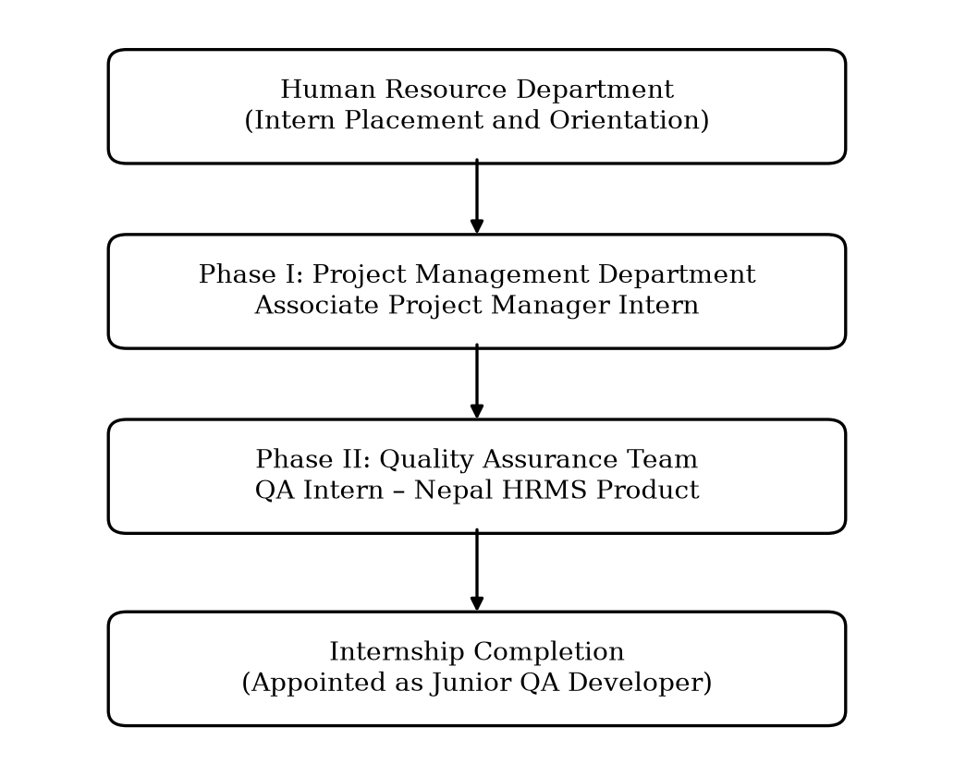
Figure 1.1: Internship Placement and Work Flow

1.3.3 Duration
The internship spanned approximately ninety working days, from 16 March 2026 to 3 July 2026. The phase-wise placement and focus areas are summarized in Table 1.1.
Table 1.1: Internship Duration and Phase-wise Placement
Phase | Department / Role | Duration | Major Focus
Orientation | Human Resource Department | Week 1 | Company policies, teams, product overview and tools
Phase I | Project Management – Associate Project Manager Intern | Weeks 1–8 | Project planning, tracking, coordination, status reporting and documentation
Phase II | Quality Assurance – QA Intern (Nepal HRMS) | Weeks 9–16 | Test scenarios, functional, regression and usability testing, defect tracking and fix validation
Total | Yoddha Lab Pvt. Ltd. | 16 March 2026 – 3 July 2026 (≈90 working days) | —

1.3.4 Activities Done
In brief, the activities performed during the two phases were as follows; a detailed analysis is presented in Chapter IV.
- Phase I: supported sprint and milestone planning; maintained task boards and trackers; coordinated meetings among development, product and operational teams; prepared meeting minutes, status updates and project documentation.
- Phase II: studied product requirements of Nepal HRMS; prepared test scenarios and test cases; executed functional, regression and usability tests; reported, tracked and retested defects; collaborated with developers on issue resolution; supported pre-deployment validation and improvement of testing processes.

CHAPTER II

BRIEF INTRODUCTION OF THE INDUSTRY

2.1 Overview of the Information Technology Industry
The information technology (IT) industry comprises organizations that develop software, provide information and communication technology (ICT) enabled services, operate digital platforms, and supply the supporting infrastructure for computing and communication. Globally, the industry has become one of the principal drivers of economic growth and employment, and software has become embedded in nearly every sector, from banking and commerce to education, health and public administration. For a developing economy such as Nepal, the industry carries particular significance: it requires comparatively low capital investment, it can export services without physical borders, and it creates skilled employment for a young workforce. The internship organization, Yoddha Lab Pvt. Ltd., operates within this industry as a software product and services company; hence the IT sector of Nepal constitutes the relevant industry context for this report.

2.2 History of the IT Industry in Nepal
The history of computing in Nepal is generally traced to 1971, when an IBM 1401 mainframe computer was used to process the national population census. The establishment of the National Computer Centre in 1974 institutionalized early data processing in the government sector. Through the 1980s, computer use expanded slowly through government agencies, banks and a small number of private firms engaged in data entry and trading of hardware.
The 1990s marked a turning point. Economic liberalization allowed private companies into the technology and communication space, and the first Internet service providers (ISPs), led by Mercantile Communications, brought e-mail and Internet access to Nepal in the mid-1990s. The government announced the first comprehensive IT Policy in 2000 with the vision of placing Nepal on the global IT map, followed by institutional and legal milestones such as the High Level Commission for Information Technology and the Electronic Transactions Act, which gave legal recognition to electronic records and transactions. During the 2000s and 2010s, a service-export segment took root, with companies providing software development and data services to clients in North America, Europe and Australia, alongside a growing domestic market for banking software, e-commerce and digital payments.

2.3 Present Situation of the Industry
At present, the IT sector is one of the most dynamic parts of the Nepali economy. Connectivity has expanded rapidly: according to the periodic reports of the Nepal Telecommunications Authority (NTA), mobile and broadband penetration now reach most of the population, providing the infrastructure on which digital services operate. A study by the Institute for Integrated Development Studies (IIDS, 2022) estimated that Nepal exported IT services worth approximately USD 515 million in 2021, indicating that the sector had already become one of the country’s significant export earners, employing tens of thousands of professionals and freelancers.
The domestic market has matured in parallel. Banks and financial institutions run on locally supported core systems and digital wallets; government services are progressively moving online under the Digital Nepal Framework (2019), which identifies eight sectors and eighty digital initiatives; and private enterprises are steadily adopting business software for accounting, customer management and human resource management. This enterprise digitization is the specific market segment in which HRMS products, including Nepal HRMS, compete and grow. Software companies in Kathmandu today range from large export-oriented firms employing hundreds of engineers to compact product startups, and recent government policy statements have prioritized IT as a key export sector for the coming decade.

2.4 Challenges of the Industry
The industry nonetheless faces persistent challenges. The most cited is the outflow of skilled human resources, as experienced engineers migrate abroad for study and employment, forcing companies into continuous hiring and training cycles. Access to international payment gateways and foreign investment remains constrained, complicating global sales of Nepali software products. The gap between academic curricula and industry skill requirements obliges companies to invest heavily in on-the-job training of fresh graduates. In addition, the small size of the domestic market limits revenue for local products, infrastructure reliability outside major cities is uneven, and public procurement of software is often slow and price-driven, which discourages quality-focused local vendors.

2.5 Opportunities of the Industry
Against these challenges stand substantial opportunities. Nepal’s young, English-speaking and increasingly skilled workforce offers a cost-competitive base for software outsourcing and remote work, a model normalized worldwide after the pandemic. Domestically, the ongoing digitization of banks, businesses and government creates sustained demand for locally relevant products — payroll and HR systems aligned with Nepali labour practice, accounting tools handling local taxation, and services in Nepali language. Cloud delivery allows small companies to sell software as a subscription with modest upfront investment. For fresh graduates, this environment translates into growing career opportunities in software development, quality assurance, product management and IT operations, which is precisely the space in which the present internship was undertaken.

CHAPTER III

BRIEF INTRODUCTION OF YODDHA LAB PVT. LTD.

3.1 Company Overview
Yoddha Lab Pvt. Ltd. is a privately held software company located in Chabahil, Kathmandu. The company builds and operates digital products for the Nepali market and provides software development services, with a compact, closely knit team spanning software development, product and project management, quality assurance, and human resources. Its flagship product, Nepal HRMS, is a human resource management system designed around the practical needs of Nepali organizations, such as support for the Bikram Sambat (BS) calendar and local holidays, attendance and leave practices, and payroll processing consistent with prevailing rules. Basic organizational information is summarized below.
- Name of organization: Yoddha Lab Pvt. Ltd.
- Location: Chabahil, Kathmandu, Nepal
- Nature of business: Software products and services
- Major products: Nepal HRMS (nepalhrm.com) and Kudos CRM (kudoscrm.com)
- Website: www.yoddhalab.com
- Contact: contact@yoddhalab.com, 9703051963

3.2 Objectives of the Organization
Based on the orientation provided by the organization and observation during the internship, the principal objectives of Yoddha Lab Pvt. Ltd. can be stated as follows:
- To develop dependable, locally relevant software products that digitize everyday business operations of Nepali organizations.
- To establish Nepal HRMS as a trusted platform for human resource management in the domestic market.
- To maintain rigorous quality standards so that products are stable and reliable before every deployment.
- To develop young IT professionals through structured internships, mentoring and full-time career opportunities.

3.3 Mission and Vision
As communicated during the internship orientation, the mission of the organization is to simplify and digitize the routine operations of Nepali workplaces through well-engineered, affordable software. Its vision is to grow into a leading product-based software company of Nepal whose platforms, beginning with Nepal HRMS, become standard tools for managing people and processes in domestic organizations.

3.4 Organizational Structure
The organization follows a flat, cross-functional structure in which small teams collaborate directly and communication lines are short. Management oversees the functional areas of human resources, product and project management, software development, and quality assurance. An indicative structure, as observed during the internship, is presented in Figure 3.1.
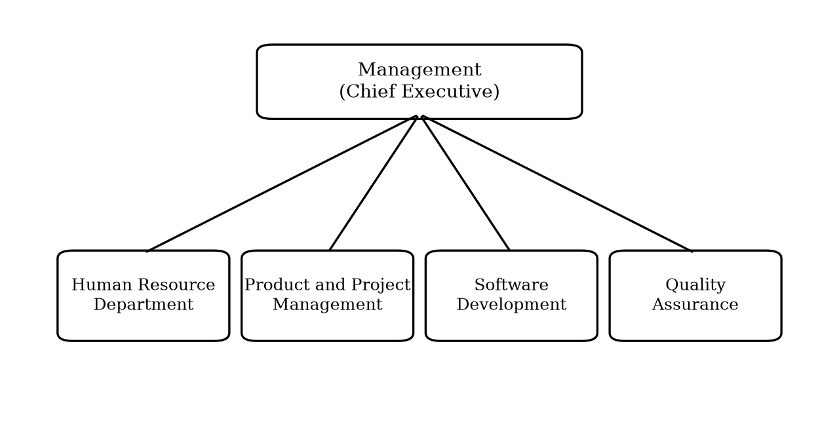
Figure 3.1: Organizational Structure of Yoddha Lab Pvt. Ltd. (Indicative)

3.5 Products and Services
The company’s central product, Nepal HRMS, brings the core functions of human resource administration onto a single cloud platform. Its major modules include employee information management, attendance with biometric support, leave management, recruitment, and payroll processing aligned with Nepali statutory requirements such as the Provident Fund, Citizen Investment Trust, Social Security Fund and electronic tax deduction at source. The product is under active development, with new modules and refinements released iteratively — a characteristic that made it a particularly instructive environment for quality assurance work, since every release cycle required requirement analysis, testing and validation.
The organization’s product portfolio also includes Kudos CRM, a customer relationship management platform on which businesses manage their customer journey — contacts, companies, leads, deals, tasks and support pipelines — from a single record. Screenshots of both products are presented in Appendix B. Alongside its products, the organization also undertakes software development work and related digital services for clients.

3.6 Present Situation, Challenges and Opportunities
Unlike the industry-wide picture presented in Chapter II, the challenges facing the organization are those of a young product company. Nepal HRMS competes both with established software vendors and with the entrenched habit of managing attendance, leave and payroll through spreadsheets and paper registers; winning customers therefore depends on demonstrating trustworthiness, since HR and payroll data are among the most sensitive records an organization holds. This raises the importance of quality assurance well above the ordinary: a payroll or attendance defect that reaches production directly affects employees’ pay and trust. On the opportunity side, the accelerating digitization of Nepali enterprises, the shortage of HR software genuinely adapted to local practice, and the subscription delivery model together give the company substantial room to grow. The organization’s practice of recruiting and developing interns into full-time staff also gives it a steady pipeline of trained personnel familiar with its products and processes.

CHAPTER IV

ANALYSIS OF ACTIVITIES DONE AND PROBLEM SOLVED

4.1 Overview of Role and Responsibilities
The activities of the internship are analysed here objective-wise, following the objectives stated in Chapter I. The internship consisted of two sequential roles. As an Associate Project Manager Intern (Phase I), the responsibilities were to support project planning, tracking and execution activities; to coordinate with development, product and operational teams; to assist in monitoring project milestones and deliverables; to prepare project status updates and maintain documentation; and to support communication between teams for smooth project execution. As a QA Intern for the Nepal HRMS product (Phase II), the responsibilities were to understand product requirements and prepare test scenarios; to perform functional, regression and usability testing of the platform; to identify, document and track bugs and issues; to collaborate with developers and product teams for issue resolution; to validate fixes and ensure product quality before deployment; and to assist in improving testing processes and maintaining quality standards. While the quality assurance work centred on Nepal HRMS, the internship also provided working exposure to Kudos CRM, the organization’s customer relationship management platform, which broadened the range of modules and workflows encountered. Together, the two roles provided an end-to-end view of how software is planned, built, verified and released.

4.2 Phase I: Activities as Associate Project Manager Intern

4.2.1 Support to Project Planning and Tracking
Work in this area addressed the first objective of gaining practical exposure to project planning and tracking. The intern participated in sprint and milestone planning meetings in which upcoming product features were discussed and broken down into development tasks. The intern helped record these tasks on the team’s project tracking board, kept task status current as work progressed, and followed up with team members on items that had stalled. Through this work, planning concepts studied in the classroom — scope definition, estimation, scheduling and iterative delivery — became concrete daily practices. The intern also learnt how plans must continuously absorb change: priorities shifted with customer feedback, and the tracking board, rather than a static plan document, served as the living source of truth for what the team was doing.
A recurring exercise was the decomposition of work. A feature request — a new report, for instance, or an adjustment to the leave approval workflow — would be discussed in planning, split into design, development and testing tasks, sized in consultation with the developers, and sequenced against the ongoing milestone. Preparing and maintaining these breakdowns gave a practical understanding of why granular, clearly owned tasks are easier to estimate, track and complete than large, loosely defined blocks of work.

4.2.2 Coordination Among Development, Product and Operational Teams
A central responsibility was helping information flow between teams. The intern attended daily stand-up meetings, noted blockers raised by developers, and made sure the concerned person — whether in product, operations or management — was informed and responded. When product decisions changed the scope of a feature, the intern helped communicate the change to developers and QA so that no team continued working on outdated assumptions. Meeting agendas and minutes were prepared for recurring coordination meetings, with decisions and action items recorded against named owners and deadlines, and followed up in subsequent meetings. This work developed precisely the professional communication skills targeted by the internship objectives.

4.2.3 Monitoring Milestones and Deliverables
The intern assisted in monitoring whether development work was proceeding according to the agreed milestones. This involved comparing the state of the tracking board against the plan, identifying tasks at risk of delay, and raising them in coordination meetings early enough for corrective action — re-prioritization, additional support to a developer, or a controlled adjustment of the milestone. The experience demonstrated how small, early corrections prevent large, late slippages, and how transparent reporting of progress builds trust between management and delivery teams.

4.2.4 Status Reporting and Documentation
The intern prepared weekly project status updates summarizing completed work, in-progress items, blockers and next steps, and maintained project documentation — requirement notes, meeting minutes, checklists and decision logs — in an organized shared repository so that any team member could locate the current version of any document. The status report format used is shown in Table 4.1.
Table 4.1: Weekly Project Status Report Format
Item | Description
Reporting period | Week start and end dates
Planned activities | Tasks planned for the week as per the milestone plan
Completed activities | Tasks completed, with reference to the tracking board
In-progress items | Ongoing tasks with current status and expected completion
Blockers / issues | Impediments requiring attention, with responsible owner
Support required | Decisions or resources needed from management or other teams
Plan for next week | Priorities carried forward and newly scheduled tasks

4.3 Phase II: Activities as QA Intern for Nepal HRMS
Phase II addressed the objectives concerning the software testing life cycle, test design and execution, and defect management. The QA team of Nepal HRMS followed a systematic testing life cycle for every release, from requirement analysis through defect closure, as shown in Figure 4.1.
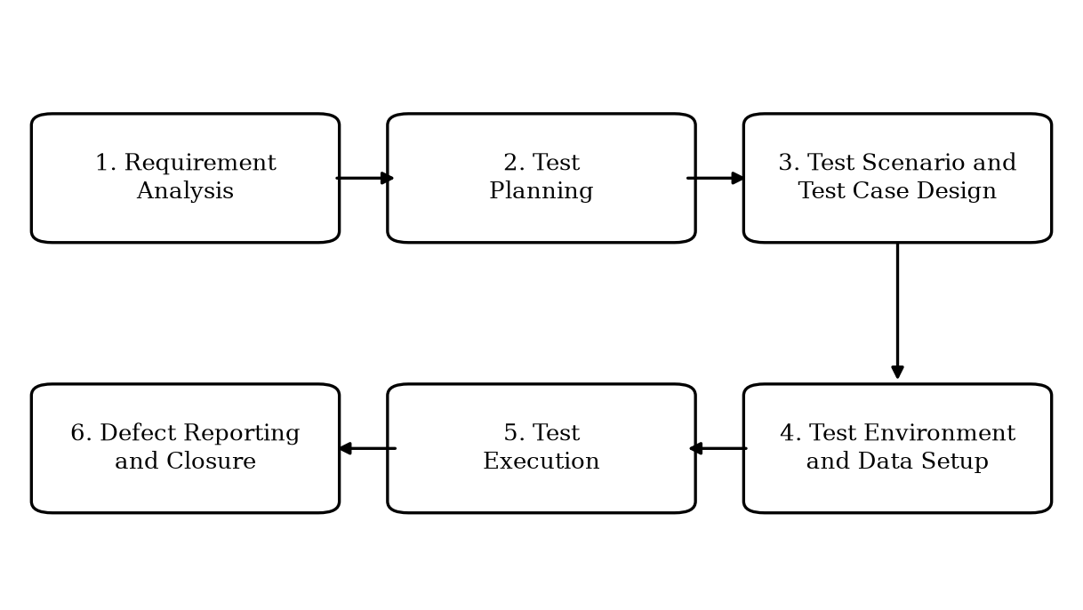
Figure 4.1: Software Testing Life Cycle Adopted for Nepal HRMS

4.3.1 Understanding Requirements and Preparing Test Scenarios
Every testing cycle began with the requirements. The intern studied requirement documents, user stories and product discussions for each module or feature under development, and raised clarification questions with the product team whenever expected behaviour was ambiguous. From the requirements, the intern derived test scenarios — high-level statements of what must be verified — for modules such as employee information management, attendance, and leave management. Scenarios covered not only the normal flow (for example, an employee applies for leave and the approver grants it) but also alternative and negative flows (overlapping leave dates, insufficient leave balance, actions attempted without permission). Scenario lists were reviewed with the QA mentor before test case writing, which taught the discipline of testing against requirements rather than against assumptions.

4.3.2 Test Case Design and Execution
Approved scenarios were elaborated into written test cases with concrete steps, test data and expected results, maintained in structured spreadsheets so that any tester could repeat them and obtain the same verdict. The intern executed these cases on the test environment, recorded pass or fail outcomes, and attached evidence for failures. The format used for test cases is presented in Table 4.2.
Table 4.2: Sample Test Case Format Used for Nepal HRMS
Field | Sample Entry
Test case ID | TC-LV-012
Module | Leave Management
Scenario | Approval of a pending leave request by the supervisor
Precondition | Employee has submitted a leave request; approver is logged in
Test steps | Open pending requests → select request → approve
Test data | Employee account, approver account, leave type and date range
Expected result | Status changes to Approved; leave balance is deducted; employee is notified
Actual result | As observed during execution
Status | Pass / Fail
Remarks | Reference to defect ID if failed

Functional testing verified each module’s behaviour against its requirements. Particular care was given to boundary and edge conditions — month and fiscal-year boundaries, leave balances of exactly zero, and records involving local calendar dates — where defects most often concentrate. The functional checks routinely performed on each module included the following:
- Input and form validations, covering mandatory fields, permitted formats and value limits.
- Role-based access control, verifying that each user role could see and perform only what its permissions allow.
- Workflow state transitions, such as a leave request moving correctly through pending, approved and rejected states.
- Calculations, including attendance summaries and leave balance deductions.
- Date handling across month, fiscal-year and calendar boundaries, including Bikram Sambat dates.
- Data persistence and consistency, confirming that saved records appeared correctly in lists and reports.

4.3.3 Regression Testing
Because Nepal HRMS was released iteratively, every fix or new feature carried the risk of unintentionally breaking existing behaviour. The intern therefore maintained and repeatedly executed a regression suite of core flows — login and access control, employee record operations, attendance capture, leave application and approval, and key reports — after each round of fixes and before each deployment. Smoke checks of the most critical paths were run first on every new build, so that fundamentally broken builds were returned to development quickly without wasting a full test pass.

4.3.4 Usability Testing
Beyond correctness, the intern assessed how easily real users — HR staff, managers and employees — could accomplish tasks. Usability observations covered consistency of user interface (UI) elements, clarity of navigation and labels, meaningfulness of error messages, and behaviour across screen sizes. Findings were reported with concrete improvement suggestions, several of which were adopted in subsequent releases, reinforcing that quality assurance encompasses the user experience (UX), not merely functional correctness.

4.3.5 Defect Identification, Documentation and Tracking
Failures observed during any form of testing were recorded as defect reports containing reproduction steps, test data, expected versus actual behaviour, environment details, and screenshot or screen-recording evidence. Each defect was assigned a severity level reflecting its impact, which guided the order in which developers addressed issues. The classification applied is shown in Table 4.3, and each defect was tracked through the life cycle shown in Figure 4.2 until closure.
Table 4.3: Defect Severity Classification with Examples
Severity | Meaning | Illustrative Example from Testing
Critical | Blocks core functionality or corrupts data; no workaround | Login failure for all users; incorrect payroll computation
Major | Important function fails; workaround difficult | Approved leave not deducted from the leave balance
Moderate | Function works but with significant inconvenience | Report filter not applied until the page is refreshed
Minor | Cosmetic or low-impact issue | Misaligned labels; inconsistent button text

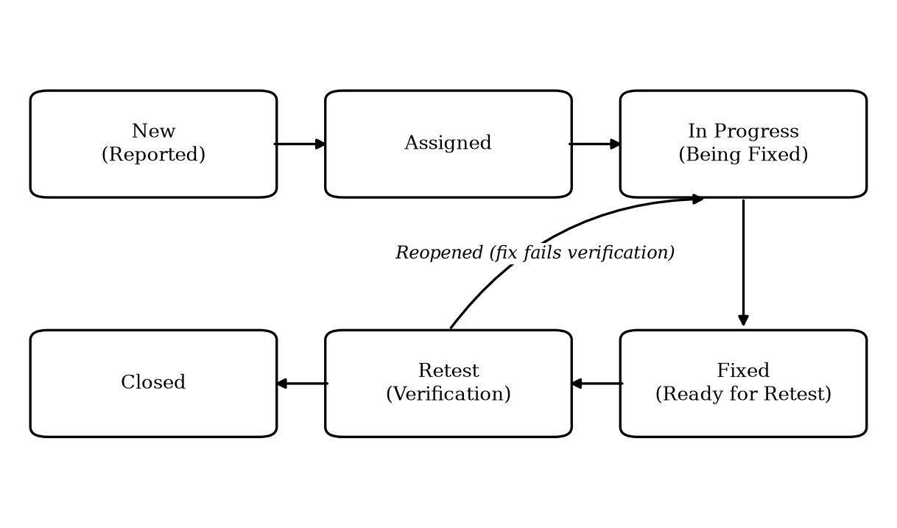
Figure 4.2: Defect Life Cycle Followed During Testing

4.3.6 Collaboration with Developers and Validation of Fixes
Defect reports were discussed with developers in triage sessions, where the intern reproduced issues on demand and clarified reproduction conditions. Once a fix arrived on the test environment, the intern retested the original defect, executed the surrounding regression checks, and either verified and closed the defect or reopened it with updated evidence. Before every deployment, the QA team performed a final validation pass over the release scope, and the intern contributed to the release checklist confirming that all planned items were tested, all critical and major defects were resolved, and core flows remained intact. This working relationship taught how testers and developers cooperate toward a shared quality goal, with clear, evidence-based reports — not blame — as the medium of communication.

4.3.7 Contribution to Testing Process Improvement
In the later weeks, the intern contributed to the QA team’s working methods: standardizing the test case and defect report templates presented above, organizing module-wise regression checklists so that coverage before releases became repeatable rather than memory-dependent, and maintaining reusable test data sets for common situations. Repetitive, stable flows were flagged as candidates for future test automation. These contributions addressed the responsibility of assisting in improving testing processes and maintaining quality standards.

4.4 Problems Encountered and How They Were Solved
The most instructive part of the internship was confronting real problems and participating in their solutions. The principal ones are described below.

4.4.1 Ambiguous and Evolving Requirements
Requirements for some features were brief or changed as customer feedback arrived, and early test cases written against them repeatedly became outdated. The problem was addressed by holding short clarification sessions with the product team before test design, recording the agreed behaviour in the scenario sheet, and noting explicit assumptions where questions remained open. Test design then proceeded from this recorded, agreed understanding, which sharply reduced rework and disputes over what constituted a defect.

4.4.2 Communication Gaps Between Teams
In Phase I it was observed that decisions taken in one meeting sometimes failed to reach every affected person, so teams occasionally worked from different understandings. The solution was disciplined documentation: minutes with explicit action items, owners and deadlines circulated after every meeting, and a weekly consolidated status update shared with all stakeholders. Once decisions had a single written source, misalignment between teams dropped noticeably.

4.4.3 Regressions After Fixes
Early in Phase II, fixes for one defect occasionally disturbed neighbouring functionality that had previously worked. The intern helped counter this by strengthening the module-wise regression checklist and making its execution a standard step after every fix round and before every deployment, with the most critical flows checked first. Escapes of this kind reaching the final validation stage were substantially reduced as a result.

4.4.4 Test Environment and Test Data Instability
Shared use of the test environment meant that test data created by one activity could invalidate another’s preconditions, producing false failures. The QA team, with the intern’s support, established dedicated test accounts and standard data sets for recurring scenarios, and adopted the practice of resetting relevant data before regression cycles. Distinguishing genuine defects from environment artifacts became far easier thereafter.

4.4.5 Release-time Pressure Versus Testing Depth
Near release dates, the time available for testing compressed while the volume of last-minute fixes grew. The team handled this tension through risk-based prioritization: severity-ranked defect triage, execution of critical payroll, attendance and access flows first, and a clear statement in the release checklist of what had and had not been covered. The experience taught that quality assurance under deadline pressure is an exercise in transparent prioritization rather than exhaustive coverage.

4.5 Tools and Platforms Used
The activities described above were carried out using the organization’s standard working tools, summarized in Table 4.4.
Table 4.4: Tools and Platforms Used During the Internship
Purpose | Tools / Platforms
Project and task tracking | Web-based project tracking board of the organization
Test documentation | Structured spreadsheets for test scenarios, cases and traceability
Defect reporting and tracking | Issue tracker used by the development team
Team communication | Team chat application, e-mail and video meetings
Documentation and sharing | Shared cloud documents and drive folders
Testing support | Web browsers with developer tools; screenshot and screen-recording utilities

4.6 Objective-wise Analysis of Achievement
Table 4.5 consolidates the analysis of this chapter by mapping each internship objective stated in Chapter I to the principal activities performed and the outcome achieved.
Table 4.5: Mapping of Internship Objectives to Activities and Outcomes
Objective | Principal Activities | Outcome Achieved
Practical exposure to project planning, tracking and coordination | Sprint and milestone planning support; task board upkeep; stand-ups and coordination meetings; weekly status reporting | Working command of project coordination practices in a live team
Participation in the complete STLC of a live product | Requirement study, test scenario preparation and review across release cycles of Nepal HRMS | End-to-end experience of the testing life cycle from requirements to closure
Design and execution of tests with systematic defect management | Test case design; functional, regression and usability testing; defect reporting, tracking, retesting and closure | Dependable defect management skills; reduced regression escapes before releases
Development of professional communication, documentation and teamwork | Meeting minutes; status updates; triage discussions; cross-team follow-ups | Confidence in clear, evidence-based professional communication
Relating BIT theory to industry practice | Application of SDLC, STLC and project management concepts on a live product | Concrete understanding of the gap between theory and practice

The mapping shows that every objective set at the beginning of the internship was addressed through concrete, repeated activities. The appointment of the intern to a full-time quality assurance position at the close of the internship stands as independent confirmation of these outcomes.

CHAPTER V

CONCLUSION AND LESSONS LEARNT

5.1 Conclusion
The ninety-day internship at Yoddha Lab Pvt. Ltd. fulfilled the objectives set at its outset. The first phase provided direct, practical exposure to project planning, tracking and cross-team coordination in a working software company; the second phase provided immersion in the complete testing life cycle of a live product, from requirement analysis and test design through defect tracking, fix validation and release readiness. The sequence of the two roles proved especially valuable: having first seen how work is planned and coordinated, the quality assurance work could be understood not as an isolated activity but as an integral stage of product delivery.
The internship also demonstrated, in miniature, how a young Nepali product company operates — how it competes for customers, guards the reliability of sensitive HR and payroll data, absorbs changing requirements, and balances speed against quality near releases. The problems encountered and solved, described in Chapter IV, were not textbook exercises but genuine issues whose solutions required communication, discipline and judgment as much as technical knowledge.
The outcome of the internship affirms its success: on completion, the organization appointed the intern as a full-time Junior Quality Assurance Developer. The internship thus achieved the highest purpose such a program can serve — converting academic preparation into demonstrated professional capability and regular employment.

5.2 Lessons Learnt
The principal lessons of the internship are summarized below.

5.2.1 Understanding of Systems and Processes
Concepts such as SDLC, STLC, iterative delivery and release management moved from textbook definitions to daily practice. It became clear why disciplined processes exist: they are what allow a team to deliver repeatedly without depending on individual memory or heroics.

5.2.2 Organizational Culture
Working inside a real team taught the norms of professional life — punctuality in meetings and commitments, ownership of assigned work, openness in raising problems early, and respect in giving and receiving feedback. The culture of treating defect reports as shared quality information rather than personal criticism was particularly formative.

5.2.3 Gap Between Theory and Practice
Classroom study presents requirements as complete and stable; practice showed them to be evolving and negotiated. Similarly, testing in theory emphasizes techniques, while testing in practice equally demands prioritization under time pressure, environment management and precise written communication. Recognizing this gap — and learning to work within it — was among the most valuable outcomes of the internship.

5.2.4 Knowledge Enhancement
The internship built concrete skills: deriving test scenarios from requirements, designing and executing functional, regression and usability tests, writing reproducible defect reports, applying severity-based triage, maintaining project documentation, and using professional tracking tools. It also added domain knowledge of human resource processes — attendance, leave and payroll — as implemented in software.

5.2.5 Confidence and Communication
Presenting weekly status updates, defending defect reports with evidence, asking clarification questions of senior colleagues, and coordinating across teams steadily built professional confidence and communication skills, both written and verbal. The ability to state a problem clearly, with evidence and a proposed next step, proved to be the single most broadly useful skill developed during the internship.

REFERENCES
Government of Nepal, Ministry of Communication and Information Technology. (2019). 2019 Digital Nepal Framework: Unlocking Nepal’s growth potential. Kathmandu: MoCIT.
Institute for Integrated Development Studies. (2022). Unleashing IT: Advancing Nepal’s digital economy and fostering an inclusive workforce. Kathmandu: IIDS.
Myers, G. J., Sandler, C., & Badgett, T. (2011). The art of software testing (3rd ed.). Hoboken, NJ: John Wiley & Sons.
Nepal Telecommunications Authority. (2025). Management Information System (MIS) report. Kathmandu: NTA.
Pressman, R. S., & Maxim, B. R. (2020). Software engineering: A practitioner’s approach (9th ed.). New York, NY: McGraw-Hill Education.
Project Management Institute. (2021). A guide to the project management body of knowledge (PMBOK guide) (7th ed.). Newtown Square, PA: Project Management Institute.
Sommerville, I. (2016). Software engineering (10th ed.). Harlow, England: Pearson Education.
Yoddha Lab Pvt. Ltd. (2026). Company profile. Retrieved from https://www.yoddhalab.com

APPENDICES

Appendix A: Internship Completion and Employment Certificate
(Attach the colour print of the Internship Completion and Employment Certificate issued by Yoddha Lab Pvt. Ltd., dated 27 July 2026.)

Appendix B: Product Screenshots
The following screenshots illustrate the products on which the internship work was performed.
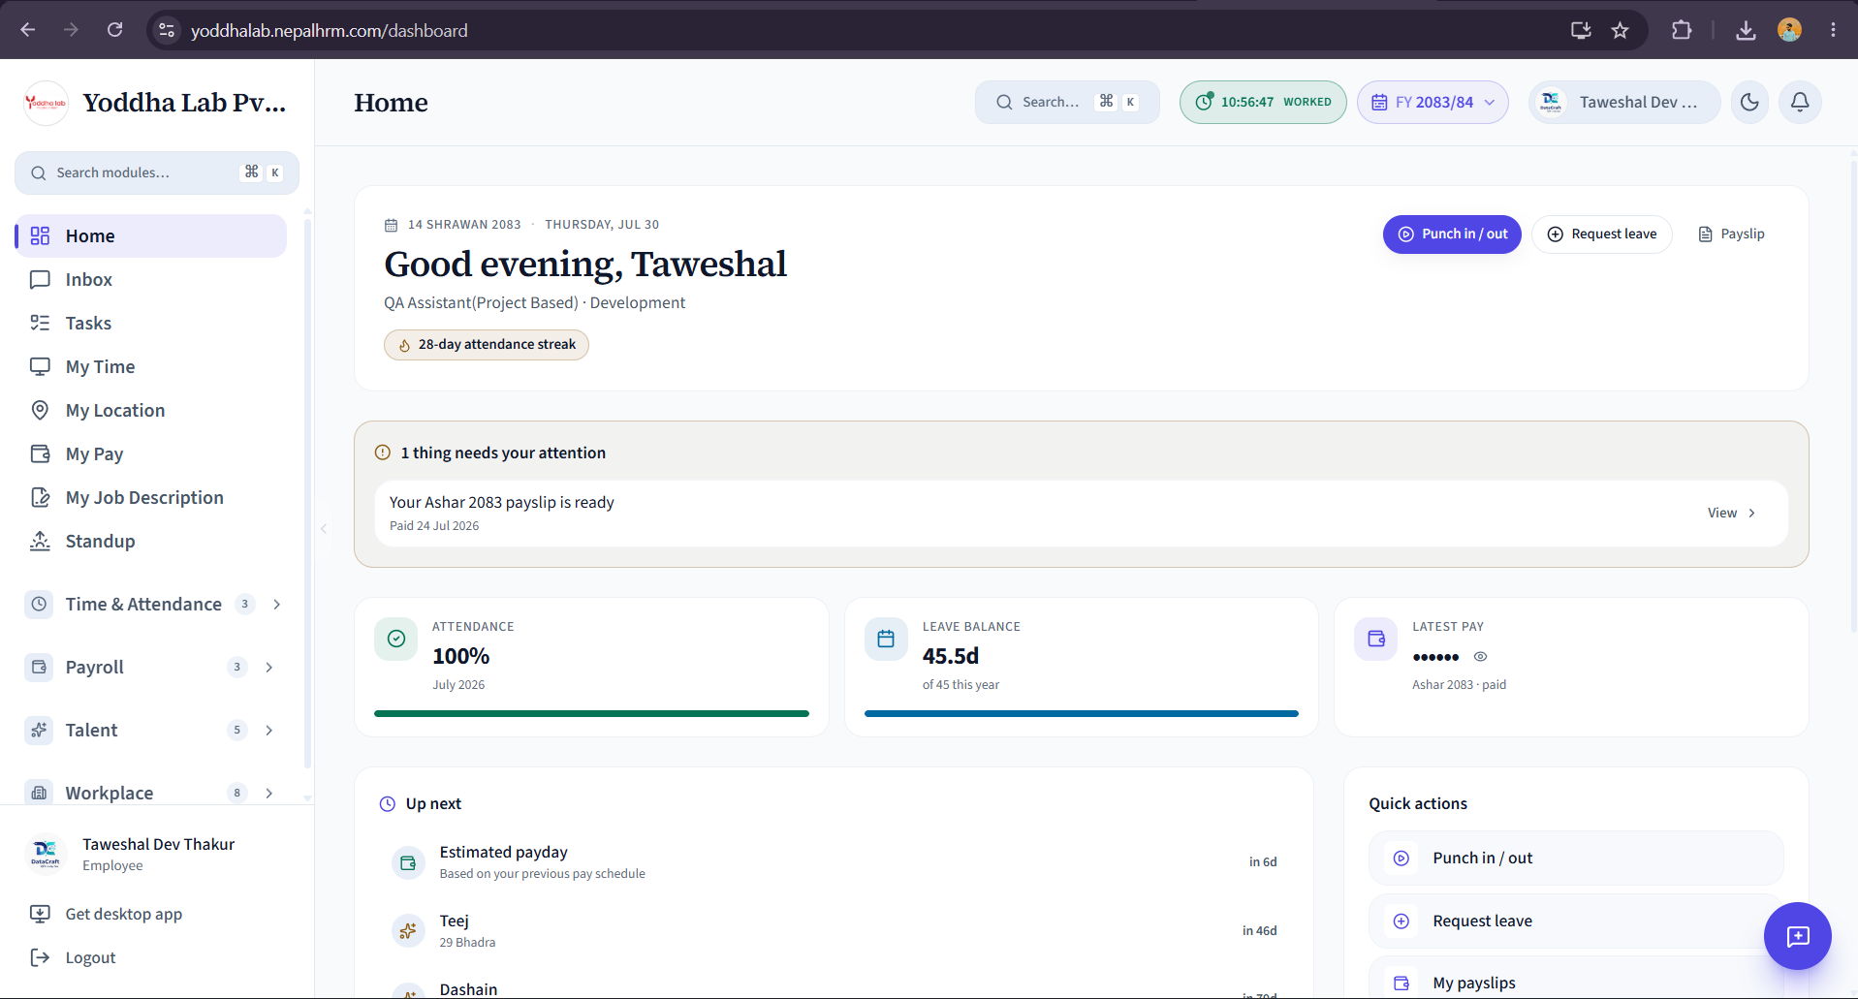
Appendix Figure B.1: Employee dashboard of Nepal HRMS (yoddhalab.nepalhrm.com)
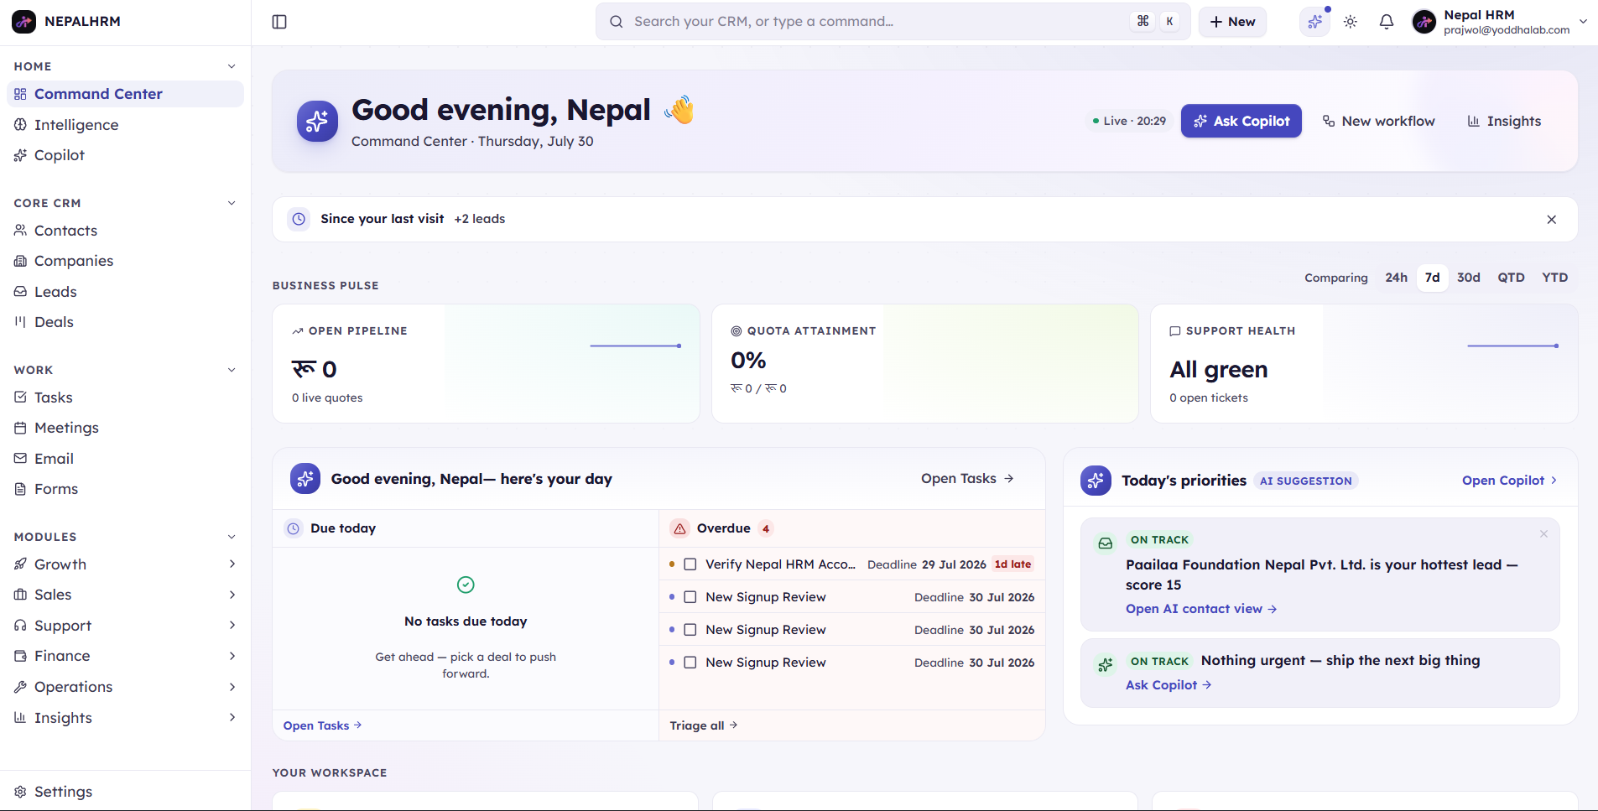
Appendix Figure B.2: Dashboard of Kudos CRM (yoddhalab.kudoscrm.com)

Appendix C: Sample Working Documents
(Attach representative samples prepared during the internship — an excerpt of the test case sheet, a sample defect report, and a weekly status report — with any confidential product data removed or masked.)

